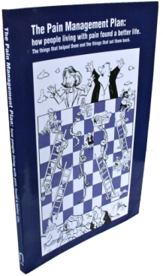

The Pain Management Plan
Training Manual

Polly Ashworth
Frances Cole
Patrick Hill
Eve Jenner
Bob Lewin

September 2012

The Pain Management Plan Training Manual
Introduction | 3
Important background information
A different way of thinking | 4
Impairment, Disability & Handicap | 5
What explains disability? | 6
The 7 targets for reducing disability | 7
Beliefs | 8 - 9
People’s self management actions | 10
Symptom Scanning and fear avoidance | 11
Motivation | 12
Confidence and Control | 13
Anxiety & Depression | 14 -15
The Tools
Cognitive-behavioural methods | 16 - 18
Organising a personal Pain Plan and Goal setting | 19 - 20
Self recording | 21
Relaxation and breathing exercises | 22-23
Helping with anxiety & depression | 24-25
Other methods in the Pain Plan | 26
The Process - what you do
Facilitating the Pain Plan step by step | 27 - 36
Index to The Pain Plan | 37
Pain Plan resources: Practitioner skills self assessment 41
Pain Plan Intervention guide 42
Patient Summary sheet 43 Body Chart and HNA 44 – 45
Pain Self Efficacy Questionnaire 46
Plan Plan Record sheet 47
Patient Feedback Questionnare 48-49

Introduction
This manual contains the information and guidance you need to become a facilitator for The Pain Management Plan, but before you start ......

You should read The Pain Management Plan book from cover to cover.

An index at the end of this manual shows you where things are in the book.

If you are not already familiar with them, make time to practice the relaxation and breathing exercises every day for at least a week before the training programme.

What is The Pain Management Plan?

The Pain Management Plan or Pain Plan is a simple home based cognitive-behavioural self management training programme for people with long term (chronic) pain. It consists of the following:
- Pain Plan part 1 (P 1-48) – the basic booklet that we want every participant to read
- Pain Plan part 2 ( P49-96) – additional information, the people choose the sections they want to read from an index at the front of the booklet
- A relaxation CD (inside back cover) – we want everyone to try this for 6 weeks
- Simple explanations: as many people will only remember a few key facts and many do not like or read books. Some people may have difficulty with new concepts and ideas.
- A short animated DVD of The Pain Toolkit summarising the key self management issues

As a facilitator, what do I do?
You meet the participant over a number of sessions to:
- Introduce the Pain Plan
- Assess the participant’s self management needs
- Discuss goals and negotiate weekly targets
- Reward the participant for progress and discuss new targets.

How much time does it take?
The first meeting should be for 45 minutes, followed by a minimum of 3 further brief contacts which may be face to face or telephone, at 1 week, 3 weeks and 6 weeks later.

What does the participant do?
Every day they practice their goals and tick them off. All participants carry out an Activity or exercise goal and practice Relaxation and breathing exercises as well as do something for Fun.
This doesn’t restrict them from working on other goals which may relate to social and/ or work related activities that they have abandoned or want to increase.

What are the potential benefits to the participant?
- Increased confidence to self-manage their pain
- Improved quality of life
- Reduced anxiety and depression
- Reduced symptom burden
- Improved health and well being

Important background information

A different way of thinking for long term conditions - the Biopsychosocial model.
Health professionals are trained and work in a context that is shaped by the ‘bio-medical model’. This is essentially a scientific model that takes an ‘objective’ approach, stressing the importance of identifying the essential components or pathogens, that are causing a health problem and treating them. More simply put; it’s a ‘find it and fix it’ approach. This is fine for acute injuries or infectious disease, but doesn’t work well for long term health conditions.

One of the unintended consequences of the biomedical model is that it dis-empowers people creating ‘passive patients’ come to rely on ‘expert professionals’ to sort everything out for them. People with long term health conditions cope better if they are supported to self-manage their conditions at home, as most of the time they won’t have a health professional around to help them.

A bio-psycho-social model is more helpful here. This model acknowledges that multiple components (physical, emotional, psychological and social) are linked in a reciprocal fashion, often feeding one another in a circular pattern. This model doesn’t attempt to identify cause, but once a long term condition has been identified, it can provide a useful starting point for a management approach. It can help people to see how things like stress and emotions can connect with their symptoms and by working on skills they can develop; such as pacing and relaxation, this will improve their confidence and ability to manage.
The Pain Management Plan is based on a practical application of the bio-psycho-social model rooted in cognitive behavioural psychology. There is a strong evidence base for the effectiveness of cognitive behavioural approaches in helping people to manage physical and mental health conditions.

What is cognitive-behavioural long term condition management?
Cognitive-behavioural methods for managing long term conditions were developed when it was realised, as we have just suggested, that medical factors alone could not explain;
- How much the condition affected a person’s life
- The amount/type of medication they were prescribed
- How soon they could return to work
- The success or failure of medical or surgical treatments.
Research showed that psychological and social factors contributed as much and sometimes more to all of these aspects.

It also became clear that simply telling people to change was often not effective; they often needed more help than education alone. Much research has shown that cognitive-behavioural methods are more effective than education alone at helping people cope with a long term health condition.

Impairment, disability and handicap
We said that you can’t explain how a person will cope with or manage a long term health condition just from looking at the medical or physiological aspects of the condition. The biology may be the starting point, but other factors need to be considered which can have a big effect on how the condition actually affects people’s lives.
A simple way to think about this is to use the World Health Organisation’s suggestion that, when assessing someone with a long term condition, you should do so on three different levels:

Impairment – or the lesion, this refers to the physiology that may be involved. Examples are, prolapsed disc, arthritis, nerve damage, the extent of scar tissue. Commonly with chronic pain there are no significant ‘lesions’ easily identified and repeated X-rays and scans do not make the problem any clearer. It is also common that identified lesions cannot fully account for the symptoms that people report.

Disability- This refers to the impact of the symptoms on people’s lives and includes things like loss of range of movement, reduced muscle tone, changes in mood, sleep disturbance and wider aspects such as loss of normal activities of daily living including work, social isolation, in comparison for what might be expected for age.

Handicap (a term more used in USA than UK) – this refers to what society does to people, on top of the disability, eg. loss of driving licence, prejudice in employment, problems getting insurance, and so on.

It is common to believe that if a person has a significant physical changes (e.g. Degenerative joints, significant nerve damage) they will be much more disabled than people with less significant changes or damage – but this is not true.

In many long term conditions there is little or no connection between the severity of the lesion or impairment and how disabled the person is day to day.

It is very important not to make a judgement about what anyone can achieve based on the severity of their lesion or impairment.

It is also important not to think that because we may not be able to identify a lesion or physical pathology that can fully account for people’s reported symptoms, that the problems are therefore psychological.

Many people begin to worry when their doctors are unable to diagnose the pain problem clearly (identify the impairment or lesion that can account for their symptoms) and start thinking that the problem is ‘all in the mind’ or that they are somehow ‘imagining’ their pain.
This is not the case, now read on.....

What does explain different levels of disability?
We all know some people whose medical findings suggest that they should be bed-bound and yet they live a near-normal life and others who have very little wrong with their body but who live like invalids. How ‘bad’ the ‘lesion’ is often has little to do with which group a person ends up in.
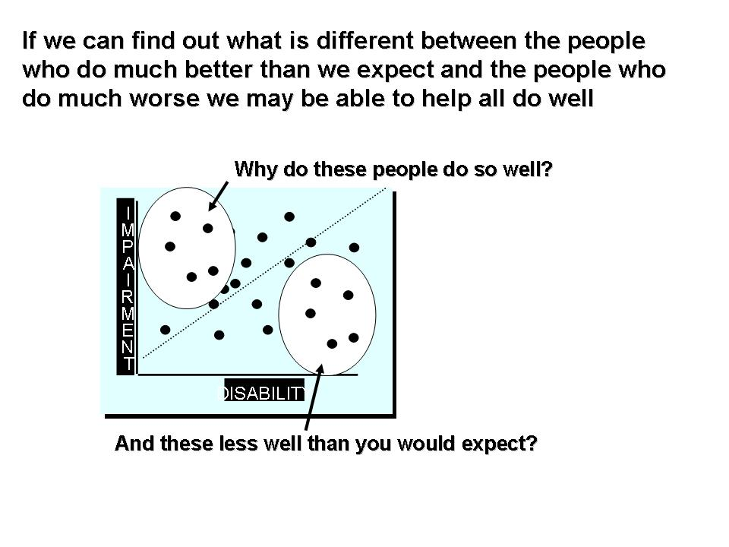These people – the ‘living miracle’ and the ‘chronic invalid’ are at different ends of the spectrum, most people are somewhere in between.
One way to find out how to help people become less disabled is to study the differences between those who do much better than you would expect and those who do much worse than you’d expect.
Many years of research have established that how disabled (or not) a person with a long term condition becomes, will depend on their:
- Beliefs about the condition
- Their own attempts to cope, such as resting to ‘cure’ the problem or, avoiding stress or activity or the over-activity rest trap are unhelpful and increase disability
- Their motivation to learn how to manage the condition(s) effectively. This is complicated as with many long term conditions; ‘I’m not going to let it beat me’ isn’t always a successful approach. More on this later
- Their confidence that they can make a difference to their situation or more importantly; to reduce their disability. The higher the participant’s confidence that they can manage the condition, the more likely it is that they will do well. Confidence that you can achieve a particular goal is known as self-efficacy
- Their sense of control over the condition or symptoms
- 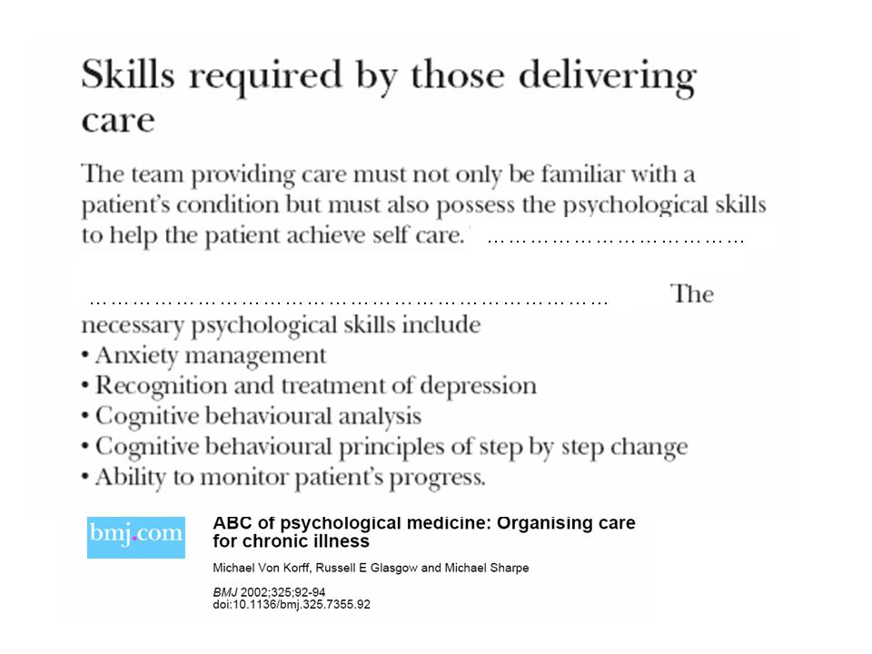Their self-management knowledge, for example, a lot of visits to A&E are often the result of anxiety about symptoms or inability to manage flare-ups in pain
- Mood. Raised levels of anxiety and depression often lead to greater disability.
There are other predictors of how well people will do, such as social class, but unlike those described above these can’t be changed through rehabilitation.
Remember education alone is not enough to change behaviour. To get the best results support should address all 7 aspects above.

The 7 targets of cognitive-behavioural rehabilitation

The next few pages will look at the following 7 targets, explain what they are and give you some ideas about how to address them. The main practical tools section starts on page 16.

- Beliefs – mistaken ideas or misconceptions

- Mistaken self management actions – over-activity rest trap, symptom scanning, fear avoidance

- Motivation - ambivalence about making change, unsure of benefits

- Confidence (self-efficacy) – increase confidence to aid behaviour change

- Control – increasing a sense of control over the pain and personal life

- Self management knowledge – taking medication correctly, balancing activity/ rest, setting realistic targets

- Anxiety and Depression – fear and hopelessness

Beliefs (See p 50-51 Understanding long term pain)
‘What we think has an important effect on our behaviour and emotions.’
This may sound obvious, but if someone does not follow our advice or act as we advise them to, we are likely to see them as stupid, lazy or not interested in being helped.
In fact the person’s behaviour may be perfectly rational, given the beliefs they hold.
The cognitive approach is to start by finding out how the person views the pain.

Pain misconceptions
Wrong ideas about the cause of the pain, or what you should do when you have it, often lead to wrong self management actions. These in turn can lead to worse health and symptoms.
For example, the misconception on the left leads to more disability and the correct belief on the right can lead to less disability, even if the impairment is the same in both cases.
Changing a belief to reduce disability
Effects of beliefs on disability
“Pain on exercise is harmful”
“Exercising sensibly won’t do any harm”

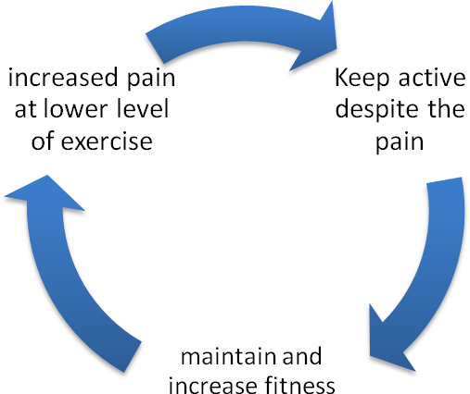
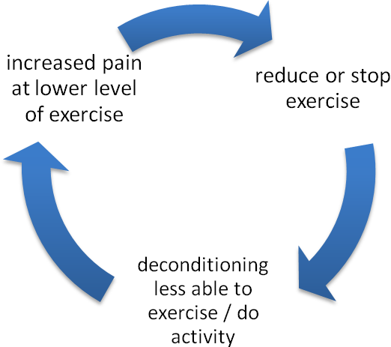

Cognitive hypothesis – unhelpful thoughts (pain misconceptions) lead to avoiding activity, becoming de-conditioned and loss of ability to undertake work and social activities leading to anxiety, depression and poor self management actions.

Misconception: my spine is crumbling
Self management action: stop exercise/ activity to avoid further damage
Result: loss of fitness & a disabled lifestyle

Misconception: if I rest the pain will go away.
Self management action: prolonged rest
Result: increasing pain as muscles become weaker and fitness is lost

Every condition has its own misconceptions.
They are usually widely believed by society.
With long term pain misconceptions are associated with:
- Cause of the pain
- Rest & activity
- Ability to return to work
- Anxiety and depression

Misconceptions can lead to wrong self management actions and anxiety and depression. Some of the common misconceptions about long term pain are shown below.

It is important to check if someone holds these beliefs (See the Quiz on p 6-7)
 | Right | Wrong
Whenever you feel pain it always means something is being damaged |  | x
People with long term pain should avoid physical activity & rest more |  | x
My X-ray showed wear & tear , my back is worn out / crumbling |  | x
Pain is just part of getting old |  | x
Rest is the best way to let my back heal |  | x
It is best to wait until the pain goes before doing things |  | x
If I’m not careful I’ll end up in a wheelchair |  | x
Exercise can be dangerous for people who have long term pain |  | x
People with arthritis should take life easy |  | x
People should fight the pain and do as much as possible ‘no pain, no gain’ |  | x
My discs are slipping in & out trapping the nerves |  | x

Accidentally confirming misconceptions
It is easy to create anxiety without meaning too; here are examples of remarks made by health professionals intended to reassure patients. Unfortunately the way that some people interpreted them simply reinforced the misconceptions they already had.

Professionals’ remarks | Patients’ interpretations
“Lie still and you’ll be alright” | “Move and you could be paralysed”
“You will be alright if you are careful” | “If I am not careful I’ll end up in a wheelchair”
“You were lucky this time” | “Next time the consequences will be dreadful”

It is a good idea to check every so often, that you have not said something that has upset or confused someone. All you need to say is something like:
“Can I just check what is it you think I’ve been trying to say?”
and at the end of a meeting;
“Is there anything we’ve discussed that has surprised you or you don’t understand?”
People often have educational needs about their condition and the things that can be done medically and by them. Without this knowledge they can’t manage their condition properly.

The good news is that wrong beliefs can be changed. This leads to improvement in symptoms, feelings of control over the condition, better self management actions, and therefore better health and quality of life.
People’s self management actions

Definition
A self management action is anything someone does to try to deal with their condition; obviously many of these are helpful; taking medication correctly, eating right types of healthy food, reading about the condition etc. Equally some are unhelpful. There are 3 very common but mistaken ways of self management that people adopt that are unhelpful. It is your job to spot these and help them change:
- The over-activity rest trap
- Symptom scanning
- Fear avoidance

Over-activity rest trap (ORT) (See p 20 – 21 The ORT)
The over-activity rest trap is common in people with chronic pain.
If you ask a group of people with long term pain if their symptoms are the same all the time, most will say; “no, the pain comes and goes, I have ‘good days’ and ‘bad days’”.
If you ask what they do on bad days they will often say something like; ‘not much’ or ‘very little’, In contrast, on good days they try to get as much done as they can, before ‘it’ comes back and they are forced to rest. They see-saw back and forwards with periods of over-activity leading increasing pain or muscle spasm followed by periods of rest to recover. This leads to:
- A loss of physical fitness and greater symptom load.
- More tiredness and lethargy.
- Less control over their life, as they are never sure of what they can do until they wake up and ‘see how they feel’. They often cancel things like shopping trips or social events at short notice.
- They feel that their health problem has taken over their life as they can no longer plan what they will do.
- They feel that their pain is getting rapidly worse making them anxious or depressed.
The ORT leads to less physical fitness because we lose fitness much more quickly than we gain it, especially as we get older. Any gain in fitness from being active on the ‘good days’, is more than wiped out by the period of resting.
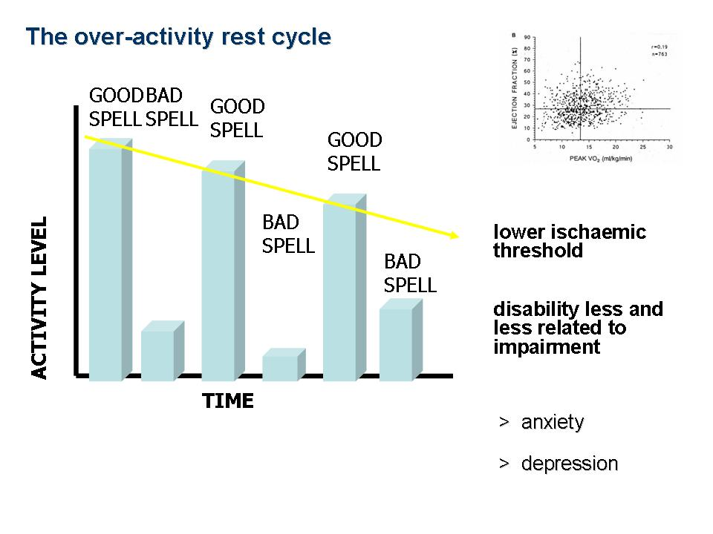People in the ORT have more symptoms such as pain stiffness and fatigue, because they are physically less fit

They feel that they are going ‘down hill fast’ even though the impairment may not have got worse. For example they think; “this time last year I could walk up that hill with no problem, now I can only get halfway up, what will I be like next year?”
This is another reason why as time goes by, there is often less and less connection between how bad the underlying ‘impairment’ is and what they can achieve, such as how far they can walk.
Symptom scanning
The over-activity rest cycle is often made worse by ‘symptom scanning’ and putting things off.
Research has shown that people who agree that you should ‘check how you feel before deciding what to do’ become more disabled than those who plan in advance and carry out that plan, even if they wake up feeling a bit ‘off’.
If they can be encouraged instead to carry out their planned actions, within a few hours they usually feel okay again. The person who has stayed in bed, or got up and sat around doing nothing, often feels poorly all day.
An unhelpful remark healthcare staff and well wishers often make is; ‘listen to your body’: Many people take this to mean don’t do anything if you feel a bit unwell, low in energy, or just ‘not quite right’ or “keep going until the pain stops me.”
This automatically leads to the over-activity rest trap.
The solution is goal setting which is described later but the motto of goal setting is:
‘do what you planned to do, not what you feel like doing’.

Fear avoidance ( See p. 68 Avoiding)
Another common but unhelpful self management action is to avoid anything that someone thinks might cause further damage or worsen symptoms.
In the case of long term pain people often feel that they have caused or aggravated their pain by doing certain activities eg lifting, bending, at home or at work. The obvious solution is to avoid work or any moderate activity. People may also have attempted to return to work and been unsuccessful. This can confirm what they are beginning to believe; that they can’t do anything.

It is important to try and get people to resume all of the activities they are afraid of, using small steps at first (goal setting).

Motivation
Simply telling people to stop unhelpful behaviour is often not enough; in fact it can increase their resistance to change. (For example think about some people’s attitudes to smoking)
Even when we know that we should improve our health behaviour we are often ambivalent, that is we can see the advantages of taking more exercise, but also the disadvantages, (e.g. no time, other things we’d rather be doing, getting sweaty and tired, etc.).
People who fail to follow health advice are often stuck in this ambivalence because the good things they will gain still don’t outweigh what they see as the disadvantages or the pain of having to change.

Motivational interviewing is a method for helping people overcome their ambivalence and they will take the first step in making changes.

The important principles are to develop a good relationship by:
- Expressing empathy - “I see what you are saying. I know, it is difficult to find time…”
- Developing rapport - asking non-judgemental, open questions (ones you can’t just answer yes or no to) about the behaviour change, “How do you feel about exercise?” rather than; “Do you want to take more exercise?”, and making it clear that you hear and respect their views, “Yes a lot of people say they can’t, because it makes the pain worse …”
- Using active listening and reflection - repeating back what has been said shows that you are paying attention and have understood; “Yes, I see, you know that walking would help but at the moment you are worried about falling.”
- Roll with resistance - it is counter-productive to get into an argument. Let the person give all of their reasons (without interruption) for not being able to make a particular behaviour change. Then set them the challenge of finding counter arguments – by saying things like “I don’t suppose you could think of any way you could get over this time problem?”
- Avoid giving your own solutions - only if they doesn’t come up with an idea of their own should you offer a solution and then give examples of other people’s solutions; ‘Someone else I was seeing tried parking their car about 5 minutes walk from work and that went quite well, she lost several kilograms in the end, just doing that little walk. The walk only took her about 10 minutes”. Never say “OK, what you should do is…”.

Help the person to take the first step and decide to act by:
Developing discrepancy - people may be worried about taking more exercise but they also don’t want to become completely weak. Ask them what they think not exercising may lead to for them. This can help them understand the difference between what they want for themselves and what their behaviour will lead to if they carry on as at present.
- Highlight the participant’s own ambivalence - let them give all of the positive reasons to change and the benefits they might get – do this by asking questions, NOT by ‘telling’ them
- Support self-efficacy - the person may believe that it is very important to make a change, yet believe that it would be impossible for them – use goal setting to set initial goals that they are pretty confident that they can manage.

Confidence (self-efficacy)
Self-efficacy is how much confidence you have in your ability to succeed in achieving a goal.
Years of research have shown that if the person perceives their chance of success as low, that is they have low self-efficacy for a task, they are less likely to try the goal or to persevere with it.
The opposite is also true; the higher a participant’s self-efficacy actually is the more likely they are to try and to succeed.
Self efficacy varies widely from task to task – you may feel high in self-efficacy for shopping, but low for working out how much interest you will pay in the next month for the resulting loan on your credit card!!

How to increase patients’ confidence:
- Set goals in small steps, so that each step means the person is likely to succeed and they themselves feel and believe they are very likely to succeed with too.
You may regard the goal as being well below their ability, or set so low that it will make no difference to their health. This is not the point. If they succeed in a first few small goals they are more likely to continue to build on this and eventually achieve a change that does improve their health.
- Use vicarious experience, give examples of other people, who are like them, who have tried and succeeded. Obviously you can’t break confidentiality and give names but it can help to tell anecdotes such as, “I had another man who is a brick layer very much like you, he did very well! He started by laying 10 bricks twice each day, now he can get manage a days work as long as he takes some breaks and paces himself.
- Use persuasion and encouragement and make it realistic. Slowly fade it out once the person is beginning to gain confidence and set new goals themselves.
- Never set goals that make people nervous or for which they feel they don’t have the strength.

Control
Feeling ‘in control’ has a major impact on our well being. It is very important to emphasise to people that they can get control of pain through good self-management.
An increased feeling of control will help to reduce stress or anxiety and depression.

Anxiety (See p 79 – 80 Anxiety)
Anxiety: what is normal? Everyone is different, some with a great deal of impairment will feel little anxiety, others with very little may be very anxious about the cause of the pain or what will happen in the future; “ If I’m like this now, what’s it going to be like in 10 years time...”
Anxiety is a useful response if it motivates us to escape from danger by changing risky behaviour like smoking. It is helpful to stress to people that we all get anxious, that it is caused by adrenaline, that adrenaline is a good thing designed to protect us and that it is common to feel anxious about the cause or outcome of pain. Stress that relaxation, practised once or twice a day, will bring their adrenaline level down.
Anxiety can also have negative effects. It can lead to unhelpful self management actions, usually protective behaviour such as avoiding activity, work, sex. This is usually because misconceptions about the pain like, “activity will cause more damage” set off adrenaline when the person thinks about having to do something physical. The same beliefs cause anxiety in relatives who then try to prevent the person from doing anything they think might aggravate the pain; “You know you shouldn’t lift anything, it always makes you worse”
Anxiety usually improves over time. It is important that people receive clear explanations about their condition and that misconceptions are corrected
Correcting misconceptions. It is part of the work of the Pain Plan to reduce these.

When anxiety doesn’t improve
Some people remain
anxious. Many people with long term pain develop hyperventilation as a habit. They may pick up on the symptoms caused by the excess adrenaline and interpret them as more evidence that they are ill, this can make them even more anxious and in some cases may result in panic attacks .

Depression (See p 85-86 Depression and Long term pain)

There are also cognitive signs :
- A feeling of guilt
- Feeling that you are useless
- Feeling that no one cares for you
- Believing that anything you try will fail
- Believing everything is hopeless or pointless.

Behavioural signs are:
- Sleep disturbance
- Unintentional weight loss
- Loss of sex drive
- The inability to enjoy the things that used to bring pleasure
- The inability to get on with tasks that have to be done
- A general lack of interest in anything
- Crying a lot
- Anger and irritability

What causes people to be depressed? Depression is not related to the extent of the pain problem. There is substantial evidence that depression is partly brought about through changes in levels of a neurotransmitter, serotonin. Drugs that alter levels of serotonin are effective against depression. This does not mean that the cause of depression is serotonin any more than adrenaline ‘causes’ anxiety.
Certain ways of thinking (perfectionism, pessimism, over-generalisation) also predispose people to depression, as do poor childhood circumstances and prolonged stress. It is clear that there is a degree of inherited disposition, yet again this is not the full explanation.
A previous history of depression is a clear risk factor for depression and if case notes or the person indicates a previous history of treatment for depression it may be simple to discuss this with them and if they are depressed to ask them to resume their usual treatment.
Self image. For some people their image of themselves as strong and powerful or very healthy may change to one of being weak and ineffective and they are ashamed.
Men who have maintained self respect and power over others through physical presence or who saw their strength or ability to work as the best thing about themselves, often become particularly distressed as they feel unable to maintain their position in the pecking order, or no longer fit for a role as the ‘defender’ or ‘provider’ of the family
Similar problems can come from a loss of role for a woman whose partner has to take over ‘her’ household tasks.
What is normal? It is normal for people living with long term pain to feel low, tearful at times and angry at others. In most cases these feelings slowly remit but in 10-20% of cases they solidify into depression.

Suicide risk - in severe depression people often think about suicide:
- If a person does admit to this you cannot ignore it. Beware of a sense of hopelessness in their thoughts and feelings.
- You should ask if they have thought how they would do it, and, if they have, ask if they have made any preparations such as hoarding pills, finding some hose pipe, etc.
- If they have made preparations, try to get them to give you these things.
- Even if their mood appears to be lifting a little the risk may not be reduced, it may have been the lethargy of depression that was preventing them from acting earlier.
- Try to persuade them to let you tell their doctor and to make an appointment for them.
- If they refuse and they have reported seriously planning their act then you should break the rules of confidentiality and contact their doctor yourself.
- Almost always, once help is summoned and treatment for depression begins to work, the person is grateful and relieved that you did this for them.

The Tools

Cognitive Behavioural methods

Cognitive methods
Discovering misconceptions:
1. Ask people what they think caused the problem and what the solutions might be.
2. Listen for misconceptions behind the words.
The quizzes in the Pain Plan will trap some of the common misconceptions, but many people will still not make the connection. If someone reports ‘giving up’ an activity, especially one that they used to enjoy, it is important to check it out further:
a) Why they gave it up? See if you can hear a misconception behind the reason for giving up.
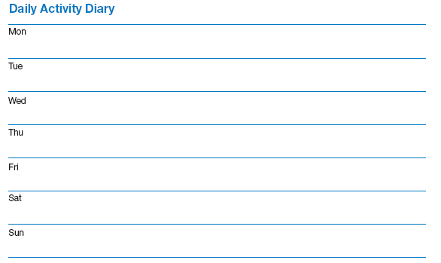b) If they’d like to get back to it?
3. Observe the participant’s and carer’s behaviours.
Are they adopting a fearful and protective life, or living life to the full? Are there periods when people either rest or overdo it for hours?
Watch how the partner or carer acts.
Do they get up to do everything for the person with pain? Do they encourage reports of pain or needing help and discourage attempts to become more active?
Over and Under protection
Do they look scared when you talk about the person doing more? Such ‘over protection’ is common; it is usually the result of a misconception in the partner’s mind that rest will protect the patient, or that excitement should be avoided. Check and discuss this with them.
Equally check that the partner or carer is not ignoring the fact that the person is fearful or struggling to do things. ‘Under protecting’ can be just as difficult to cope with and can stop people from pacing themselves.
Changing misconceptions:
1. Don’t simply contradict the person’s beliefs: use ‘motivational interviewing techniques’ to avoid increasing resistance.
2. Point out parts of the Pain Plan that deal with misconceptions and use the explanation there for how this can lead to a restricted and fearful life.
3. Use goal setting (discussed later). Sometimes a discussion is enough to convince someone that their belief is wrong, but often you are fighting folklore, cultural, religious beliefs or misunderstandings of things said by other staff and their friends and family!
Using goal setting for a feared activity and setting small steps that do not arouse anxiety in the person or their carer, is one of the best ways for the person to ‘prove’ to themselves and others that increasing activity is not dangerous or harmful.
Once they have direct experience that their worries were groundless, their belief will often change spontaneously.
Behavioural methods
Behavioural ‘laws’ were discovered by psychologists trying to explain what makes us behave in some ways and not in others. They apply to all animals and mostly operate below the level of conscious thought.

The most important behavioural rules are:
- Behaviour that is rewarded increases in frequency (or, left to our own devices we do more and more of what we enjoy and less and less of what we don’t}. By rewarding ourselves or others for behaviours that we want to encourage, we can increase the number of times they happen.
- 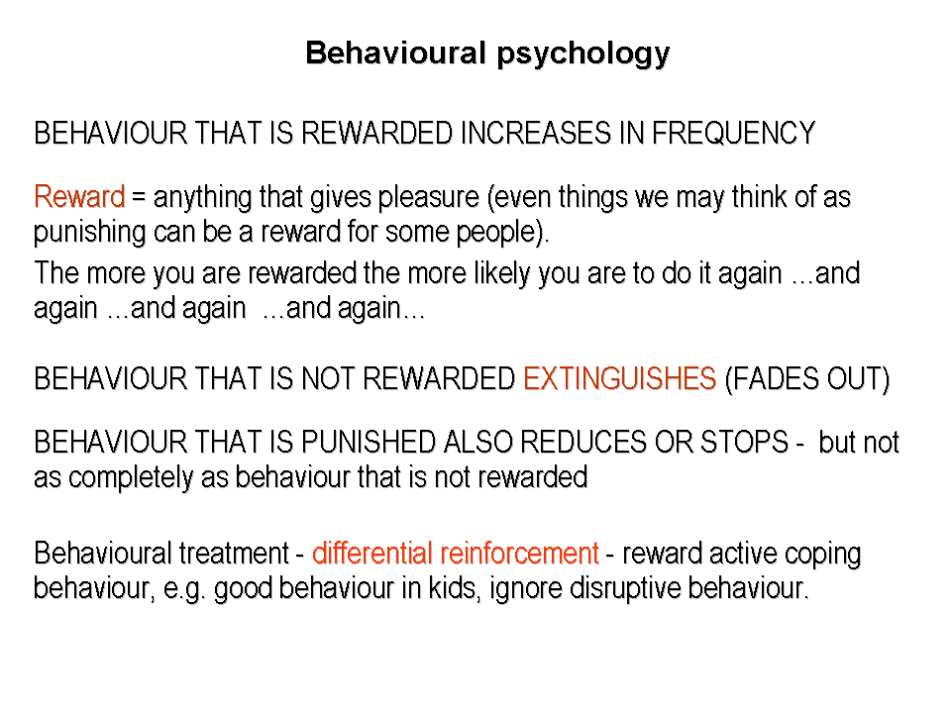The closer in time the reward is given to the behaviour that you wish to increase, the better it works.
- If all rewards stops after a while the behaviour will cease. (‘extinguished’)
- Making no response or reward is more effective in extinguishing unwanted behaviour than punishment.

Rewards ( see p 34 and the REST test)
It follows from this that it is very important, if we want to change behaviour, that the new behaviour, say taking a walk every day, is pleasurable (rewarding) or at the very least, not punishing (unpleasant). The following actions will all make it more rewarding:
- Self-recording: ticking off tasks as they are achieved is rewarding for most people.
- Build rewards into the target: for example, arranging for a daily walk to end at a café where they can treat themselves to a coffee or paper from a shop. Activities that are enjoyable to the person, like dancing, swimming, gardening, can be used instead of a formal exercise programme.
- 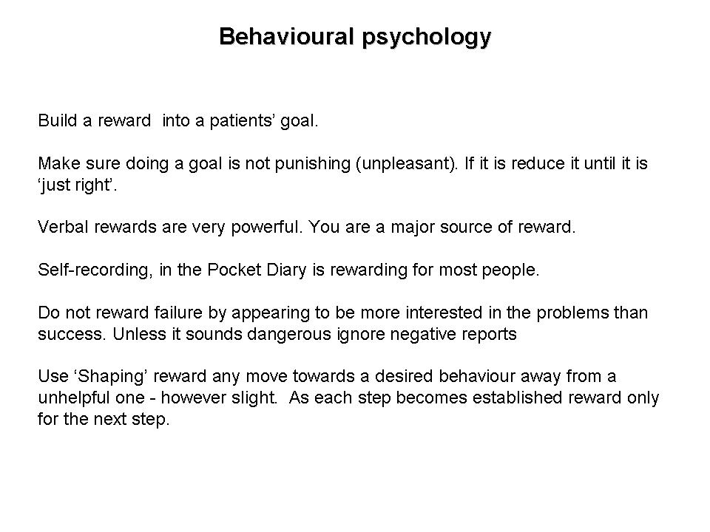Verbal rewards are very powerful; almost all of us like praise.
- You are a major source of reward: every time you praise someone’s efforts or just show an interest. Almost all people will work hard to hear your congratulations, don’t let them down!
Use rewards carefully - they can be counter-productive:
- Don’t reward failure - attention is rewarding for most people. By showing more interest in the problems people report them rather than the good times, feeling well and coping. We can reward having problems, rather than dealing with them.
As healthcare workers, because of our emphasis on, diagnosing, looking for risk or new health problems, we often pay symptoms more attention than health and well being!
People with long term health conditions, quite unconsciously, start to work for attention by telling us about problems, not success; they’ve found that this gets more interest and seems to please us more than talking about feeling better.
Carers often do the same and people can, quite unintentionally, be conditioned into increased disability.
So, unless it sounds dangerous, ignore reports of failure, niggling symptoms, strange new aches or pains, bad days - and save your attention and rewards (congratulations, smiles, etc.) for self management statements, optimistic ideas. This is called selective attention (or differential reinforcement).
- Use shaping – shaping is a very powerful method for changing behaviour. You reward any move at all from a current unhelpful behaviour towards a more desired behaviour even if in itself it will not lead to better health. As each step becomes established – for example, walking for 5 minutes, the new threshold for getting a reward becomes walking for 10 minutes.
Potential problems
Obviously being too obvious or patronising in using praise is going to have the opposite effect to the one you are seeking.

Objections to behavioural methods
This may all sound very manipulative, unnatural or patronising, but actually, without being aware of it, you are already using rewards and selective attention every time you interact with someone. It is impossible not to.
Good and effective clinicians use these techniques in the way described above often without being aware of it.
You can improve your success with people by deliberately using behavioural rules to their benefit. It is unethical not to use the best methods available to help someone with a long term health condition.

Decades of research has shown that behavioural techniques can produce very large effects on behaviour.

Organising a personal Pain Plan and Setting goals (see p 28 – 35)

Goal setting is key to getting out of the ORT without a pain flare up, increasing involvement in pleasurable activity and developing skills such as relaxation. Becoming skilled at goal setting is very rewarding and is the most important skill for helping people change.

We would like you to encourage everybody to set goals in 3 areas:
- Activity goal
- Relaxation practice daily for at least 6 weeks
- Fun goal

Definitions – Goals and Targets
Goals :The goal is what the person wishes to achieve: eg, get back to work, lose 10kg, be able to walk 5km, get back to playing golf.

Targets: The target is the short term goal that you set with the person on the way to the goal. Eg. walk 500 metres, twice a day every day for a week.

The steps in goal setting are to:
- Establish clearly what people wish to achieve; the goal. This may be losing weight, to become stronger, to have fewer symptoms, or get back to gardening or DIY.
- Set a target that they agree they could carry out even on a ‘bad’ day. Get agreement that this means they will be able to do it every day.
- Meet regularly to reward progress and help the people set new goals.

Goal setting has the following effects:
- Builds up physical fitness painlessly and safely
- Overcomes fear avoidance and the over-activity rest trap
- Reduces anxiety and depression

Goals may be general eg: ‘lose weight’, ‘get stronger’, ‘do my garden’, ‘get back to work’, but..
Targets should be S M A R T E R:
- Specific – “I’m going to exercise more” is no good, “I’m going to go for a 30 minute walk everyday in my lunch hour” is excellent
- Measurable –“I want to be able to do my own gardening” is a goal, but not specific enough for a target. “I’m going to do 20 minutes gardening five times a week” is a good target, it is clear if it has been achieved or not
- Achievable – nothing is less helpful than failing a target or a goal. “I’m going to lose 20kg in the next 2 months” is unrealistic and will almost definitely fail. This is punishing and lowers self-efficacy. “I’m going to lose 500g a week” is more realistic and if exceeded is even more reinforcing
- Rewarding – behaviour that is rewarded increases, behaviour that is not, decreases.
- Time bound – goals are more likely to be carried out if a specific time is agreed in advance

Increase self-efficacy by setting targets at the right level
If someone gives a score of more than 5, choose a less demanding one.
A task that is too easy is not rewarding and does not increase the feeling of self-efficacy.

Common problems:
- Complex goals. Many goals have to be broken down to a series of smaller targets. For ‘decorating’, you will have to ask the person where they will start; perhaps it is stripping the wallpaper. The first target should be something like, ‘stripping wallpaper for 5 minutes every day’ Getting back to golf would involve - walking, the ability to carry clubs, repeatedly hitting the ball. Goals have to be set for each of these separately.
- Falling into the over-activity rest trap by doing more than the goal that was set. Doing more than the target should never be praised, indeed it should be criticised, and the problem of the over-activity rest trap should be explained. The motto is – ‘do what you planned – not what you feel like’ and this should be repeated regularly.
- Raising targets too quickly. Impatience can be a problem, particularly when the person becomes more confident, it can lead to doing too much and thus to the over-activity rest trap.
- Competing. Some people can’t help but compete – they always try to beat their best time or do better than others. This can lead to the over-activity rest trap.
- Having a ‘flare up’. When the person has had a flare up in their pain, they should resume at a level which they judge will be ‘just right’ i.e. 5 out of 5.
- Going on holiday. Some goals (walking, relaxation) should be taken along with the person. If the people stop they should treat it as above.
- People with no goals. It is helpful to have a list of activities to suggest. If they have been very inactive and never had any hobbies use this list to discuss some new ones.

Subsequent contacts reviewing success and resetting targets.
The most important part of goal setting is the reward and increase in self efficacy it brings.
At every meeting you must look at every goal and reinforce every example of success. If you do not do this goal setting can become a negative force.
Ask; “How do you feel the [target] is going, is it getting easier?” The idea is that they learn to increase targets and add new goals as they become more fit and active.

Precautions
If someone tells you that they are having increased pain or are struggling with targets that they previously found ‘just right’, check if it is because they are doing more at other times, or because of a change in routine (having visitors, busy social life etc.), or if they are more stressed and not sleeping well (financial problems, carer problems, bereavement).
If there does not seem to be such a simple explanation or they have a change of symptoms that can’t be explained, they made need to review the problem with their doctor or clinician.

Self-recording (see p28 -29)

Self recording is intrinsically rewarding and a powerful method for behaviour change in its own right.

Weekly Record Sheet for goal setting
We would like you to encourage everybody to set goals in 3 areas
- 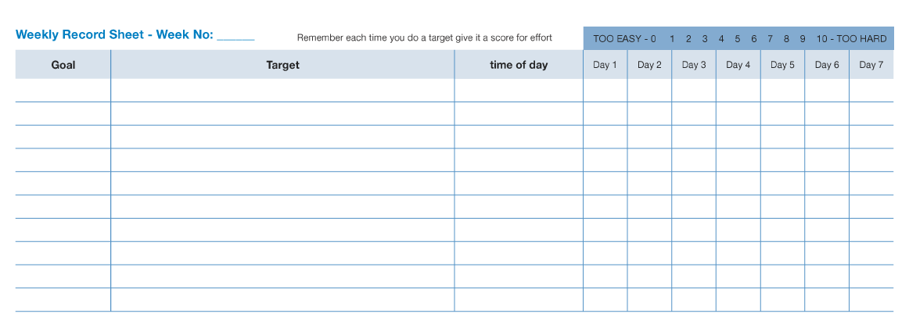Activity
- Relaxation
- Fun

These should be entered in the first 3 rows of the record.

- As many more goals and targets as the person agrees to should be entered.

- All targets should have a time of day allocated to them.

- All targets should be scored for effort. If they score more than 5 for effort the target should be reduced. This makes it far more likely that the person will comply and succeed.

Relaxation and breathing (see p 13-16 and 57-58)

Relaxation has a number of benefits, some psychological and some physiological. We ask that people try it for 6 weeks, as this has been shown to be when the benefits begin to become obvious.

Resistance to trying it. Some people may feel that it is a bit ‘hippy’, or that it is like hypnosis, neither is true. It may be worth telling them that most of the world’s top sports people have a sports psychologist who teaches them to use relaxation to improve their performance.
Around 50% of people will take to it almost immediately and carry on using it for at least a year, 20-30% will struggle at first but begin to appreciate it after a few weeks. The rest will remain unimpressed or never try it.
It is important that it is treated like any other goal and that you ask people how they are progressing each time you see them.
Ask them if they experienced any of the following and congratulate them if they did.

- Sensations that show a person is becoming relaxed whilst practising:
- Warm hands and feet
- A feeling of lethargy and unwillingness to act or move
- A warm comfortable state of contentment and security
- Increased saliva production
- A lack of muscle tension
- A feeling of sinking into the chair or bed, or of floating above it

- Changes that show someone is benefiting:
- Generally feel more relaxed
- Warmer hands and feet
- Better sleep
- Less agitated
- Less irritable

- Precautions and considerations for practice:
- Choose a time and place when you won’t be disturbed
- Ask others to leave you in peace for the 20 minutes you need
- Don’t practise with others
- Don’t practise where, if you fell asleep, you might fall over
- Don’t listen when driving
- Take a moment or two before you stand up

Difficulties in learning to relax: (see p 95 -96)
- Not practising is the most common reason for not making progress
- The mind wandering leading to annoyance - just bring your mind back to the taped voice and carry on from there.
- Expecting something more, worrying that it is ‘not working’. Relaxation is not an altered state of mind, it will be working whether it is obvious or not, worrying about it will prevent relaxation.
- Falling asleep – suggest practising in a recliner type chair not bed, at a time when they are most alert and to keep eyes open.

Very rare problems:
- Unwanted unpleasant memories or thoughts - If this is persistent the breathing exercises may be a better option than relaxation. If the thoughts are about physical or sexual abuse you should ask if they want to see someone to discuss this further.
- Panicky feelings - usually these feelings can be overcome by doing the exercises sitting upright in a recliner type chair with eyes open.
- Dislike of one of the voices on the recording - try another recording, there are many on the market.

Breathing retraining
Many people hyperventilate, causing anxiety and strange symptoms. Breathing retraining can help in two ways, better breathing will reduce adrenaline, and the person will calm down by concentrating on their breathing.

Three steps to better breathing:
- Teaching people to recognise incorrect breathing
- Teaching abdominal breathing; this takes a lot of practice, the method is fully explained in the Pain Plan booklets
- Setting up mechanisms so that the person checks their breathing pattern regularly

To demonstrate the breathing technique to the person whilst seated:
- Place one hand on your chest and one on your abdomen
- Try to breathe just with the abdomen, just easy breaths, so that as you breathe in your abdomen rises, and as you breathe out your abdomen falls
- The hand on your chest should remain still, while the hand on your abdomen should rise and fall with the breathing.

Helping with Anxiety & Depression (see p 79-86)
Anxiety : Observation and talking to the person can also identify that there is a problem. Behavioural signs are agitation, poor concentration, problems sleeping and all of the other symptoms of high adrenaline shown in Part 2 of the Pain Plan ( See p 61)
Discussing anxiety. Healthcare staff are often too embarrassed to talk about mental health issues and many people will resist the frightening idea that there is “something wrong with my mind.” Talk about adrenaline not anxiety or fear instead. In the Pain Plan the metaphor of ‘adrenaline level’ is used to describe a continuum from worry through to, at the high end, anxiety. You can use the pages of the pain plan to explain what is happening. No-one can be blamed for having a chemical in their blood so you should explain to people that other explanations they may have thought of, such as; cowardice, weakness, being stupid or having a sanity problem are all wrong.
The role of thoughts. The responses to stress are not only physiological, but involve cognitive factors such as the meaning of what is happening, memories of previous experiences and the response of others around you.
Helping people deal with anxiety. The ways in which the Pain Plan helps to reduce anxiety include:
- Dealing with long term pain misconceptions - for example, my spine is crumbling and I will end up in a wheelchair’ This thought will automatically trigger off adrenaline
- Normalising the symptoms - it helps to remind people that adrenaline is helpful and normal: read Part 2 to see why this is helpful
- Relaxation - for 20 minutes a day will bring adrenaline down
- Goal setting as systematic desensitisation - one of the main tasks of adrenaline to get us to run away from dangerous situations. Unfortunately every time that we avoid something it makes us more anxious, the next time we are faced with the same situation.
- This can become a phobia - a phobia is when a harmless object or situation produces a high level of adrenaline. The best treatment for a phobia, is systematic desensitisation, a technique very similar to goal setting. Low levels of the activity that the person is anxious about are practised until they no longer trigger the release of adrenaline. The person then chooses to raise the target a little, this may make them anxious on the first few occasions but as long as the step has not been too steep this too soon becomes unthreatening.
- Increasing activity levels. - moderate exercise lowers the levels of adrenaline. Keeping active also means less time to observe symptoms and to worry about them. The very act of encouraging people to do more suggests to them that you do not think they are going to do any harm.
- Increasing perceptions of control - stress and anxiety begin when situations are perceived as beyond our control. Changing risk factors provides control. You can use this by rewarding reports of success; “that’s great, you are really getting control over your pain”.

Depression

What can you do to help?

- Pain misconceptions are related to depression and changing them is related to a reduction in depression

- Encourage feelings of control over the symptoms or the condition
- Normalise the symptoms. Adjusting to a changed view of one’s future is a normal part of coming to terms with living with a long term condition. This process has been likened to the grieving process:
- Struggling to believe what has happened
- Anger
- Depression
- Acceptance.
- It is important that the person does not become distressed by being distressed. Assuring them that crying and feeling sad is quite normal and almost always passes.
- It can help to label the emotion as being a function of serotonin and removing it from the area of sanity, psychiatric condition or personality weakness
- Shaping active self management -, low mood leads to a lack of motivation, it is particularly important to encourage and reinforce any move towards an active response or any positive statements
- Goal setting to increase activity levels- goal setting can be used to help people get back to activities that are no longer participated in that were once enjoyed. Initially these may no longer provide pleasure, it is important to stress that this will return if they allows some time. It will help if you have a list of local voluntary activities, or clubs and a list of hobbies to use as a prompt for things to do.
- Listing negative thoughts - people struggling with negative thoughts may benefit from trying to write these down and checking them with another person. If they choose to share them with you it is important to try not to contradict these ideas outright, but to ask questions that will help the person to find a more realistic thought for themselves.
If nothing helps:
- Referring on - people who are clinically depressed at your final meeting should be referred to their doctor or to a clinical psychologist or psychiatrist. You will need to discuss this with them first. Explain that you don’t question their sanity in any way, that everything they are feeling is understandable and normal, but that, as with many people in their situation, you want them to at least discuss how they feel with the doctor to see if he or she can do anything to help.

Other methods in the Pain Plan

Contracting
Research has shown that, although it has no legal status, and it is not clear why it works, getting people to sign a contract can help them to adhere to a programme. Part of the first meeting with the person involves asking them to ‘sign up’ to the programme.

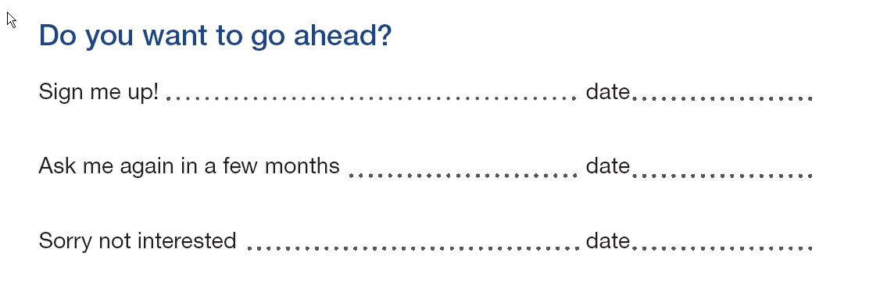

Process: facilitating the Pain Plan
What follows requires practice. After a while it will become second nature. It is broken up into a series of ‘Steps’ and there is a prompt card, to remind you of all of the steps.

Some general pointers:
- Stick to the script. Later you may develop a routine that you find works better but we know from training many people that if you try to make up your own method from the start you are likely to take far too long and still not cover all of the important points.
- Timing of each section. We’ve given rough timings for each step but these are only a PAIN PLAN : If a person has no misconceptions and is clear about what caused the problem, steps 2-4 may only take a couple of minutes.
- If the person has many misconceptions and is very talkative 15 minutes may have gone and you may still not have tackled a lot of the wrong ideas. Then you need to stick to the maximum time limit (15 minutes for step 2). Say something like,
“That’s very interesting and there are quite a few things there we need to talk more about but we need to get on – could you fill in this quiz here ( on page 6) before next week and we can look at it next time we get together.”
- Very talkative participants. There is a skill in interrupting people who have gone off topic or are taking the scenic route. It can feel rude (at first) but the only solution is to interrupt,
“That’s interesting, we can come back to that later if we have time, but what I really want to understand is ..”
Talkative people enjoy talking and will not be the least offended IF you have given them another topic to talk about. The difficulty is how you feel. We are taught not to interrupt and to take turns in talking. Luckily talkative people are not aware of this convention so they are rarely offended if you switch the conversation. Don’t reinforce over-talkativeness by going on smiling and nodding even though the person won’t let you get a word in.
- Use selective reinforcement. Reinforce with smiles, nods and comments (good, that’s great, well done) self management statements or reports of success, such as “I’m going to learn to manage my pain”, “I’m going to lose weight”, “I’d like to try and get a bit fitter”, “I think I feel a bit better” and so on. Remain neutral, or ignore, depressing, self-put-downs or defeatist talk. “I never manage to do anything properly”, “I was born lazy”, “It’s all my own fault” etc. This can feel cruel but it will help people take a more active and optimistic view.
- Practice. Try and get a few friends, relatives or colleagues to act as the person with pain whilst you practice going through the introduction and sign up.
Tip: Have another run through just before you see your first person, even if you have to do it on your own. Practice saying the words given below out loud to yourself, and handing the booklets across to an imaginary patient, opening the diary to the right pages etc. It may feel very strange but it will help you be much more fluent when you are doing it for real.
First Meeting (45 minutes)

Step 1. Engage with the participant. (5 minutes)
- It is important to appear interested, knowledgeable, relaxed and confident.
- The first five minutes should be spent getting to know each other.
- Don’t chat about the condition, instead try and find any common ground, people you know, places you’ve been, things you like etc.
- The more you can establish such connections, the more the person will trust you.
- If they have come alone, ask if they have a partner or friend who could come next time.

Step 2. Check the participant’s beliefs about what caused the problem and the best way to cope with it. (5-15 minutes)
- Ask them, “What do you think caused your back pain?”
- Listen without interrupting. Reflect back what they have said, even if you know it is wrong.
e.g. “So you think that it runs in the family? A lot of people think that, but we’ve not been able to find any scientific evidence for it just being inherited or genetic.”
- Then ask; “What do you think could improve/solve the [problem]?”
Reflect back what they have said, use questioning to try to change any misconceptions.
e.g. “So you think that you need to be more careful and rest more. Do you think rest will strengthen your back?”
If they say; “No I don’t suppose so”
You can say; “You are right, in fact a lack of activity can prolong your back pain and doing more can reduce the chance of further problems.”
- Use your knowledge of misconceptions to try and correct their ideas.

Tip. If you have read the Pain Plan several times, especially the quiz, you will already know some of the ‘better thoughts’ that you can use with the participant.

- Try to spot any mistaken self management actions and correct them.
For example, if the over-activity rest trap is obvious say something like,
“Actually it may seem good to do as much as you can on a good day. It is the wrong way to deal with long term pain problems. It would be good if you could read these pages here [Page 20 about ORT] before we get together again, your family may like to read it too.”

Finally say something like
“there are a lot of ideas about chronic pain that are wrong. Your family and friends may have these ideas. We’d like you all to have a go at this quiz here on page 6 before I see you again. See what they think – you’ll be able to put them right!”

TIP: The person may give you several opportunities to use ‘hooks’ to increase their motivation to do the programme. If they mention having given up a hobby or not being sure if they can still do it – explain that is just the sort of thing the programme will help them with in achieving.
Don’t get into a big discussion about it now – that is for the goal setting stage.
If the person is obviously nervous mention the words “get back to things in safest way possible” several times.
In other words find out what the people goals are and offer to help with them.

Step 3. Explain the PAIN PLAN programme (deal with ambivalence using motivational interviewing). Make the contract. (2-10 minutes)
Say something like;
“Now I want to talk to you about the PAIN PLAN Programme, it is designed to help you learn to manage your long term pain problem and get it under control. Research has shown that it can make a real difference.”
“We go through the things that might help you and you can choose any you’d like to try, now or later. Or if you decide you don’t want to do try of them you don’t need to. Would that be OK?”
If the person asks what sort of things, say something like
“Well we look at what might have caused your pain problem and at things you can do to learn to manage it better”
If the person is not sure use motivational interviewing techniques.
Start with a reflective and open question, such as
“It seems you are not sure about doing it. What are your concerns?”
Reflect back their worries
“So you’re not feeling too well just now and you don’t feel you’ve got the energy to take on any more. What do you hope to feel like in the future?”
If they say something like, “less tired” or “I just want to feel better again” Say something like
“So one of your goals is to be less [ill, restricted, back to normal] have you thought how you can achieve that?
If they say something like “I need to build myself up” reinforce the good self management statement by saying something like,
“That’s great, that is just what the PAIN PLAN programme is all about; building yourself back up in the safest, best way possible. It starts from what you can do quite easily now and you choose how much to do as you feel better.”
If the person says “I just need to rest” say something like
“Did you know that your back is supported by muscles? Do you think resting makes muscles stronger or weaker?”
If the person says, “I don’t know”
Say “Well that is what the PAIN PLAN is for to show you how to get back to better health”
Try to meet any other objections with similar questions (not statements).
Other techniques are to use examples of other people (vicarious learning),
“I had a lady a few months ago who came on the programme and, just like you, she wasn’t sure if she had the energy, so we started slowly and now she is managing her pain really well.
Establishing the contract
Once the person agrees to take part say something like,
“These are the booklets. This is Part 1. If possible we’d like you to read it before we meet next time. You may also want to look at some of the topics here [show index Part 2] and read some of these when you have time.”
“Today we’d like you to look at understanding why you have long term pain and see if you want to begin to work towards managing it.”
We ask everyone to agree to choose some daily exercise to do and, if possible, to practice relaxation every day from this tape, it takes about 15 minutes or so”
“Do you want to go ahead?”

If the person says “yes” say something like,
“That’s great, all of the things we are going to do will really help you get back to normal and beat further problems, could you just sign here please?”

If the person has not agreed to take part say something like,
“Well I can see that at the moment you don’t feel like doing this, but can I give you this to take home to look at. It’s for your family too (page 89) and then perhaps I could phone you in a few weeks time? Just to see how you feel.”

Get them to sign the ‘Ask me again…’ line.

TIP: some people will not want any help what ever you do.
Leave the door open by parting on good terms and, if agreed, check with a phone call in a month.
Don’t beat yourself up if they don’t take part. As long as you have tried to present the options in the manner described above you have done all that can be expected.
People are responsible for their own actions.

Step 4 Weekly record sheet (Goal setting pages 22 and 28 - 35)

Purpose
This is the main tool in the PAIN PLAN .
This is where the people sets their goals and ticks them off each time they do it.
Goal setting is the main way to get the person active and back to a normal life.
Read page19 to remind yourself of principles, especially SMART.

Remember we want people to set goals in 3 areas:
- Activity goal
- Relaxation practice daily for at least 6 weeks
- Fun goal

How to introduce
Activity - Walking
“Now you remember we said that we would set some targets? Walking was one, this is where we write it down and each time you do it I want you to give it a score for how hard it was. Some people make the mistake of doing nothing until they feel better and others do as much as they can until they have to stop. Both methods are wrong, it explains why in here [show Book 1] those people often take much longer to get back to normal some never do. The best level to exercise at is just right, 5 out of 10.”
“Let’s take walking. We want to find a walk you can do every day, that will not be TOO HARD, look here, 10 out of 10 [point to blue strip across top right], nor TOO EASY, no effort at all. What we want is a five out of ten, half way between too hard and too easy.”
“So, can you think of a walk you could do every day that would be just right, 5 out of 10?”
Discuss suggestion with patient, remind them they have to get back again, then under ‘Goal’ write ‘get fit’, under ‘Target’ write down (or get them to write down) a brief description, e.g. ‘Down to first oak tree in the lane’. ‘To paper shop.’ ‘To bottom of the garden x 2.’ And get them to write down a time of day. If they are in work then you may have to negotiate their lunch hour, before work or after work.
“That’s great, so next time I see you each day will have a score in this box for how hard the walk was each time you did it. We’ll put 5 in because that is what you think it will be. If you are wrong and it is too hard just do one a bit shorter. You need to do it as soon as you’ve finished, not when you’ve rested. Does all this sound complicated?”
“Well, it is all written down in the Pain Plan”,
“As the days go by the target will get too easy, when it scores less than 5 for 3 days in a row, you should increase it so that it will be a 5 again. You’ll need to start a new line for the new goal, you’ll see an example in the Pain Plan . Don’t worry if you are not sure, we will meet again in a week and I can help you put the target up.”

Activity
“Activity was another thing that you wanted to step up: it could be working in a gym or a sport but it could also be a hobby or pastime. Do you have any active hobbies?”
Use motivational interviewing to work out one or more activities that are of moderate intensity and set goals as for walking. If they can’t think of anything, try things they did and enjoyed as a kid. Have a list of local group activities, mention things other people did, vicarious learning again.

Relaxation
“The other thing we like everyone to try is the relaxation. It is all explained here in the PAIN PLAN and on the CD. Can we choose a time? When would be a good time? You need to be left undisturbed when you do it.”
“OK, write relaxation under Goal. And listen to CD under Target, and 10 am, here under time. Obviously if for some reason you can’t do it at that time one day you can still do it later”

Fun
Something like;
“You said that you’d like to see more of your friends ”
Use your motivation interviewing skills, try and get the person to suggest what they want to do. One way is to plan contacting and arranging to meet someone using goal setting.

Daily living, hobbies and social activities
Ask;
“Are there any things you’ve given up that you’d like to be able to do, or things you want to get back to that you are not sure about? Goal setting is the best way to get back to things safely”.
Things that may come up are work, housework, sports, etc. Use goal setting, writing each down on a separate line.
Or,
“It is important to be as active as possible, we should all be moderately. Are there any activities or hobbies you used to enjoy or that you’ve always wanted to try that you’d like to have as a goal?”
And,
“It is really important not to give up on your social life. Do you like to go out?”
Visiting family, the cinema, dancing will all help to increase the people confidence .
Step 5. Sum up and fix next meeting. Make any notes (5 minutes)

Purpose
- To encourage the person to feel that they can gain control.
- To reward them for all of the positive things they are doing and that they have planned to do as goals.
- To make sure that you have not created any misconceptions.
- To answer any questions that they have.
- To set the next meeting.
Doing all of these makes it much more likely that they will come to the next meeting.

Turn to Weekly Goal Sheet
“You’ve got off to a great start, you’re going to do this walk each day that will start to get you fit again and help you lose weight, and you’re going to start to do some gardening. You are going to try the relaxation and read about the Pain Plan programme. Next week we’ll go through your goals to see how they went. Could we get together on … “

“Finally, is there anything we’ve said or done that has surprised you or left you feeling worried or upset in any way?”

Make notes after the person has left, if you have not made them during the meeting.

Second and subsequent meeting

Purpose
To
- Review Goal sheet, praise self management activity, look for evidence of fear avoidance or over-activity rest trap. Question long periods of inactivity, suggest new goals as alternatives, e.g. social visits, hobbies, use the local resource sheet

- Check goal setting targets. Warn against over-activity rest trap if the person is doing much more on one day than another or taking days off activities. Check that the target scoring is understood and being used correctly. Encourage the person to take action.

- Praise success

- Problem solve any difficulties

- Discuss how they are using medicines ( if appropriate)

- Discuss raising the existing baselines for the following week.

Other things to consider

Anxiety or depression
Goals, look for new social goals, activities that are likely to be maintained because they are enjoyable.

Final meeting with participant

Purpose
May be face to face or by phone or email / chat room

To
- Review goals and targets, discuss how they can continue to use goal setting to get to the goals. Discuss strategies for keeping the activities going, joining a group, having a variety of different activities if one gets boring.

- Praise success

- Discuss raising the existing baselines for the following week.

- Check misconceptions

- Discuss maintenance

- Review gains

- Ask them to complete the evaluation questionnaires

First Meeting Prompt Card

Step 1. Introductions (5 minutes)
Engage with person with pain and partner / carer

Step 2. Check beliefs about cause and solution. (5-15 minutes)
Ask about “What do you think caused [your long term pain]. Use active listening and reflective techniques

Step 3. Explain the Programme and make the contract (5-10 minutes)
Explain the Pain Plan programme
Use motivational interviewing to assess interest and self-efficacy
Establish a Contract

Step 4. Introduce Goal Setting (25-35 minutes)

Weekly Record Sheet – Goal setting

Goals must be specific, measured, achievable, rewarding, timely (?)

Step 5. Sum up (5 minutes)
Encourage and praise effort
Review goals and targets
Check no new misconceptions, provide contact details, arrange next meeting

The Pain Management Plan Index
A |  | M
Activity | 17 | Medication | 93
Goal setting - increased activity | 22 | Menu Part 2 | 49
Over activity rest trap | 20 | Mike’s story (Pain journey) | 87
Adrenaline | 61
Anger and pain | 69 | N
Anxiety | 79 | NATs and PATs | 83
Avoiding | 68 | Negative thinking | 82
B |  | O
Breathing for relaxation | 15 | Overactivity Rest Trap | 20
Breathing - checking | 57 | “Oh no!” Thoughts | 64
Breathing exercise | 58
 |  | P
C |  | Pain cycle | 8, 26
CD for Relaxation-using | 96 | Pain flare ups and setbacks | 52
Chemicals to fight pain | 83 | Pain journey - Mike’s story | 87
Choosing what to do | 27 | Painkillers and other medicines | 93
 |  | Pain Plan – setting up your own | 28
D |  | PATs | 83
Depression | 85 | Pete – more about stress | 59, 74
Distraction for better sleep | 76 | Physical activity | 17
E |  | Q
Early Warnings ( Flare ups) | 54 | Quiz - Long term pain | 6
Elle’s Goals | 28
Endorphins – our own chemicals | 25 | R
 |  | Relationships | 89
F |  | Relaxation
Five (5) |  | - Breathing for | 15
- steps to a pain plan | 34 | - Learning about | 13
- things keep people in pain cycle | 26 | - Problems learning relaxation | 95
- solutions people recommend | 27 | - Questions about | 14
Flare ups | 52 | REST test | 34
Causes | 52
Coping with | 56 | S
Early warnings | 54 | Set backs
 |  | Coping with a flare up or setback | 56
G |  | Setting up own pain plan | 28
Getting started | 35 | Sleep | 75
Goal sheets | 36 | Stress
Goal Setting for increasing activity | 22 | - Of pain | 10
 |  | - Busters | 72
H |  | - How we see things … | 60
How we see things causes stress | 60 | - More about stress | 59
 |  | - “Oh no!” trap | 62
I
Ideas about long term pain | 5 | T
 |  | Tension – spotting | 11
J |  | Treating long-term pain | 51
Josh and the Pain cycle | 8 | Thoughts – “Oh No!” | 64
K |  | U
Keeping people in the pain cycle | 26 | Understanding long term pain | 50
 |  | Using the relaxation CD | 96
L
Living with pain | 1 | W
Long term pain is different | 4 | What is the pain plan? | 2
Low spirits | 81 | Worrying about sleep | 77

My Workshop Notes

My Workshop Notes

Pain Management Plan skills (before training)

NAME DATE

Rate your current level of understanding and confidence to apply each of the following knowledge and skills when working alongside people with long term pain

My current confidence or understanding to enable people with pain to:  0 = no confidence/ no idea and 10 = totally confident / understand fully. | Rating  (0 - 10)
- Boost their self esteem and confidence
- Understand the role of relaxation & breathing skills and use resources available
- Problem solve their own difficulties
- Increase their physical activity and get fitter
- Use pacing skills (manage their activities) daily
- Identify their own goals (setting/planning/achieving)
- Be assertive in managing their needs
- Manage setbacks or flare ups in their pain condition
- Gain more acceptance and adjustment to their pain condition and its impact
- Understand and use their medication to best effect
- Find support networks or other options to sustain their self management skills
Now rate for yourself using scale
0 = no confidence/ no idea and 10 = totally confident / understand fully
- Understanding faulty pain systems
- Working with people with pain to help them identify their needs and priorities for change using health needs assessment tool (HNA)
- Understanding unhelpful moods of depression, anxiety and anger and unhelpful thinking patterns
- Understanding a person centred model (Five areas Model: cognitive behavioural model) and its role in working with people with pain
- Enable individuals to increase their confidence to self manage using the Pain Plan workbook

 | Structure of Pain Plan Intervention
1 | Session number 1, Week 0, Face to Face  Aims: Complete baseline measures, Introduce plan, goal setting & relaxation, get started on goals.
- Measures: HNA, PSEQ, PDQ
- Introduce pain plan and explain structure of further apts.
- Introduce Goal setting:
    - Introduce goal setting and use Health Needs Assessment to identify goals.
    - Write in first goals, checking using REST test.
    - Check understanding & confidence - Adjust goals as needed, recheck REST.
- Introduce relaxation
- Arrange review appointment or phonecall at one week
- Agree Homework: eg (1) Read Part 1 (2) Try relaxation (3) Work on planned goal
2 | Session number 2, Week 1 , Face to Face or phone  Aims: Early review of goals, Introduce part 2
- Review participant’s engagement/ understanding
- Goalsetting: Check in on goal progress since last week, encourage and reward effort
- Review reading of Part 1: Check reading and understanding of pacing and stress
- Review relaxation. Assist to problem solve, encourage to go onto next relaxation track
- Arrange review appointment or phone call
- Agree Homework: eg (1) Targeted reading (2) Continue relaxation (3) Work on planned goals
3 | Session number 3, Week: As planned, Face to Face or phone  Aims: Continue review
- Review progress on goals and reset.
- Review reading of part 2, pick up on relevant issues, add to goals as appropriate
- Discuss pain beliefs
- Arrange review appointment or phonecall. Agree Homework
4 | Session number 4 (Optional) Week: As planned Face to Face or phone
 |  | - Optional (content could mirror session 3 agenda above)
5 | Session number 5 (Optional) Week: As planned Face to Face or phone
 |  | - Optional (content could mirror session 3 agenda above)
6 | Session number 6, Week: 12, Face to Face  Aims: Repeat measures, Review progress and finish/refer on
- Measures: PSEQ, PDQ, satisfaction questionnaire
- Review progress on goals and set new or continuing goals
- Identify remaining needs or signpost to other services/ resources, etc

Pain Plan Summary  Diagnoses | Name:  Date of Birth:  Hospital Number:  (or affix hospital label here)
(1)…………………………………………. | (Main diagnosis)
(2)………………………………………….
(3)………………………………………….
(4)………………………………………….
(5)………………………………………….
Is there any other treatment ongoing at the same time as Pain Plan?

No / Yes, please describe: ………………………………………………………………………

Consent
Data
Baseline (date....................) |  | Completion (date……………….)
BHNA
PSEQ |  | PSEQ
PDQ |  | PDQ
 |  | Satisf Q’re completed | Yes / No
 |  | Total no. sessions

Comments
( e g. missed sessions,+ & - changes in medication, progress/ barriers reported, flare ups/set backs )

Pain Chart
Name:
Date of Birth:
Hospital Number:
(or affix hospital label here)

What is the main area that you have pain?............................................................

Please help us understand the pain you are feeling by using the body chart below

- Please draw on the picture where you feel pain or any other sensations for example pins and needles

- Please describe below what the pain feels like for example sharp, aching, burning

Use symbols below if it helps

Burning | Tightness or discomfort | Ache
====== | oooooooooo | xxxxx
====== | oooooooooo | xxxxx

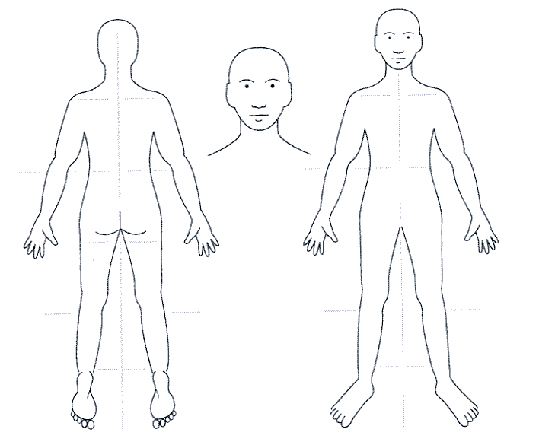

Name:

Date of Birth:

Hospital Number:

(or affix hospital label here)

Changing how pain affects your life (HNA)

Pain can affect peoples’ lives in many ways. This questionnaire lists some of the problems and difficulties due to longstanding pain.
Please help us understand the main problems at present that you feel are important to improve your quality of life and self manage with more confidence.
Please tick √ the boxes below related to your needs.
Name Date of Birth

Do you have any problems or difficulties with:-
1 |  | Walking or moving about
2 |  | Lack of fitness and energy
3 |  | Balance or recurrent falls
4 |  | Side effects or other problems with current pain medication e.g.  tablets etc.
5 |  | Pain relief
6 |  | Understanding why longstanding pain occurs
7 |  | An unhelpful pattern of activity of doing too much, getting more pain, then doing too little
8 |  | Eating the right sort of foods
9 |  | Disturbed sleep
10 |  | Managing mood changes of depression, anger, anxiety or worry
11 |  | Tiredness or lack of energy
12 |  | Relationship difficulties; with partner, family, work etc
13 |  | Sex life
14 |  | Remaining in work or returning to work and/or training
15 |  | Financial or money difficulties
16 |  | Current legal claim linked with the pain problem
17 |  | Concerns about your carer/partner, their health or other problems
18 |  | Other difficulties that you feel are important to change, for example, concerns about housing, hobbies, leisure or social events with friends or visiting the church or mosque. Please describe here ......................................................................................................................
Final step: If you ticked more than three areas of your life, please circle the three most important to change at present.
Thank you for helping us to understand your needs.

Your logo
Name:
Date of Birth:
Hospital Number:
(or affix hospital label here)

& service name

Date…………………

1) Managing your pain (Pain Self Efficacy Questionnaire)

Please rate how confident you are that you can do the following things at present, despite the pain. To answer, circle one of the numbers on the scale under each item, where 0 = "Not at all confident" and 6 = "Completely confident".
 | For example: | Not at all  confident |  | 3333 |  |  |  |  |  |  |  | Completely  confident
 |  |  | 0 |  | 1 | 2 |  | 3 |  | 4 | 5 |  | 6
Remember, this questionnaire is not asking whether or not you have been doing these things, but rather how confident you are that you can do them at present, despite the pain.
 |  | Not at all  confident |  |  |  |  |  |  |  |  |  | Completely  confident
I can enjoy things, despite the pain. |  |  | 0 | 1 |  | 2 |  | 3 |  | 4 | 5 |  | 6
I can do most of the household chores (e.g. tidying-up, washing dishes, etc.) despite the pain. |  |  | 0 | 1 |  | 2 |  | 3 |  | 4 | 5 |  | 6
I can socialise with my friends or family members as often as I used to do, despite the pain. |  |  | 0 | 1 |  | 2 |  | 3 |  | 4 | 5 |  | 6
I can cope with my pain in most situations. |  |  | 0 | 1 |  | 2 |  | 3 |  | 4 | 5 |  | 6
I can do some form of work, despite the pain ("work” includes housework, paid and unpaid work). |  |  | 0 | 1 |  | 2 |  | 3 |  | 4 | 5 |  | 6
I can still do many of the things I enjoy doing, such as hobbies or leisure activities, despite the pain. |  |  | 0 | 1 |  | 2 |  | 3 |  | 4 | 5 |  | 6
I can cope with my pain without medication. |  |  | 0 | 1 |  | 2 |  | 3 |  | 4 | 5 |  | 6
I can still accomplish most of my goals in life, despite the pain. |  |  | 0 | 1 |  | 2 |  | 3 |  | 4 | 5 |  | 6
I can live a normal lifestyle, despite the pain. |  |  | 0 | 1 |  | 2 |  | 3 |  | 4 | 5 |  | 6
I can gradually become more active, despite the pain. |  |  | 0 | 1 |  | 2 |  | 3 |  | 4 | 5 |  | 6

Name:
Date of Birth:
Hospital Number:
(or affix hospital label here)

Pain Plan record sheet

Date …./…./….… Session No ………. Face to face / phone contact

Duration of session / phone call …………………….

Record of intervention

Goals set:
Goal no. | Goal
1

2

3

4

5

Your Feedback on the Pain Plan
Please mark x in the box next to your answer.
- Was The Pain Plan explained clearly?
Yes Mostly Yes Mostly No No Don’t know

- Do you feel there was enough time in your sessions?
Yes Mostly Yes Mostly No No Don’t know

- Was the information easy to understand?
Yes Mostly Yes Mostly No No Don’t know

- Did you feel confident to work on your goals at home?
Yes Mostly Yes Mostly No No Don’t know

- Do you feel you had enough support?
Yes Mostly Yes Mostly No No Don’t know

- Would you recommend The Pain Plan to other people?
Yes Mostly Yes Mostly No No Don’t know

- Overall, do you feel The Pain Plan has helped you?
Yes Mostly Yes Mostly No No Don’t know

- In what way did you receive support in using the Pain Plan?
Face to face only Mixture of face to face Phone calls only & phone

- Would you have been interested in using…
Email Facebook Skype Other ideas?........................................

Please could you tell us:

- How has The Pain Plan helped you or why it wasn’t helpful?

- What was the best thing about The Pain Plan?

- What was the worst thing?

- How do you think we could improve The Pain Management Plan?

Do you have any other comments about The Pain Plan?

Thank you

